Chapter 6
Visible Surface Detection

Visible surface detection or Hidden surface removal is major concern for realistic graphics for identifying those parts of a scene that are visible from a chosen viewing position. Several algorithms have been developed. Some require more memory, some require more processing time and some apply only to special types of objects.

Visible surface detection methods are broadly classified according to whether they deal with objects or with their projected images.

- Object-Space Methods (OSM):

An object-space method compares objects and parts of objects to each other within the scene definition to determine which surfaces, as a whole, we should label as visible.
E.g. Back-face detection method

- Image-Space Methods (ISM):

In an image-space algorithm, visibility is decided point by point at each pixel position on the projection plane. Most visible-surface algorithms use image-space methods.
E.g. Depth-buffer method, Scan-line method, Area-subdivision method

- List Priority Algorithms

This is a hybrid model that combines both object and image precision operations. Here, depth comparison & object splitting are done with object precision and scan conversion (which relies on ability of graphics device to overwrite pixels of previously drawn objects) is done with image precision.

E.g. Depth-Sorting method, BSP-tree method

A. Back Face Detection Method (Plane Equation method)

In a solid object, there are surfaces which are facing the viewer (front faces) and there are surfaces which are opposite to the viewer (back faces). These back faces contribute to approximately half of the total number of surfaces. Since we cannot see these surfaces anyway, to save processing time, we can remove them before the clipping process with a simple test.

Each surface has a normal vector. If this vector is pointing in the direction of the center of projection, it is a front face and can be seen by the viewer. If it is pointing away from the center of projection, it is a back face and cannot be seen by the viewer.

The test is very simple, if the z component of the normal vector is positive, then, it is a back face. If the z component of the vector is negative, it is a front face.

Principle:
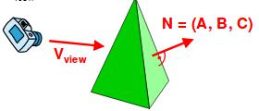

- Remove all surfaces pointing away from the viewer

- Eliminate the surface if it is completely obscured by other surfaces in front of it

- Render only the visible surfaces facing the viewer

Back facing and front facing faces can be identified

using the sign of V • N where V is the view vector and N is normal vector.

- If V • N > 0, back face

- if V • N < 0 front face

- if V • N= 0 on line of view

Numerical

Q. Find the visibility for the surface AED where an observer is at P (5, 5, 5).

Here,
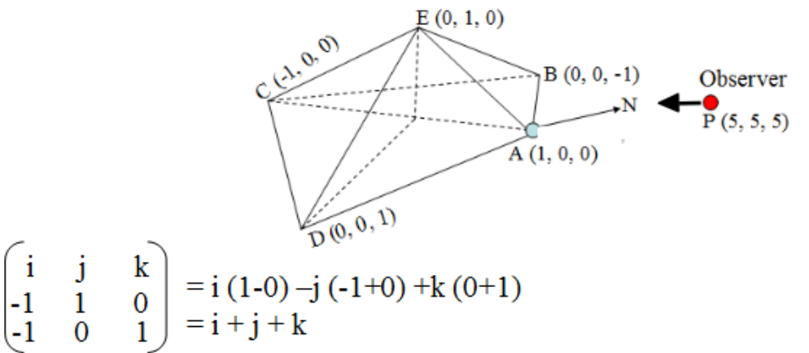

AE = (0-1) i + (1-0) j + (0-0) k = - i + j

AD= (0-1) i + (0-0) j + (1-0) k = - i + k

Step-1: Normal vector N for AED

Thus, N = AE x AD =

Step-2: If observer at P(5, 5, 5) so we can construct the view vector V from view point A(1,0, 0) as:

V = PA = (1-5) i + (0-5) j + (0-5) k = -4i - 5j - 5k

Step-3: To find the visibility of the object, we use dot product of view vector V and normal vector N as:

V • N = (-4i - 5j – 5k) • (i + j + k) = -4-5-5 = -14< 0

This shows that the surface is visible for the observer.

Q. Find the visibility of n1 and n2 from V.
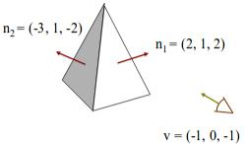

n1 • v = (2, 1, 2) ·(-1, 0, -1) = -2 – 2 = -4,

i.e n1 • v< 0

So, n1 front facing polygon

n2 • v = (-3, 1, -2) ·(-1, 0, -1) = 3 + 2 = 5

i.e n2 • v > 0

so n2 back facing polygon

B. Depth Buffer (Z-Buffer) Method

This method is developed by Edwin Catmull and is an image-space approach. The basic idea is to test the Z-depth of each surface to determine the closest (visible) surface.

In this method each surface is processed separately one pixel position at a time across the surface. The depth values for a pixel are compared and the closest (smallest z) surface determines the color to be displayed in the frame buffer.
It is applied very efficiently on surfaces of polygon. Surfaces can be processed in any order. To override the closer polygons from the far ones, two buffers named frame buffer and depth buffer, are used.

- Depth buffer is used to store depth values for (x, y) position, as surfaces are processed (0 ≤ depth ≤ 1).

- The frame buffer is used to store the intensity value of color value at each position (x, y).

The z-coordinates are usually normalized to the range [0, 1]. The 0 value for z-coordinate indicates back clipping pane and 1 value for z-coordinates indicates front clipping pane.

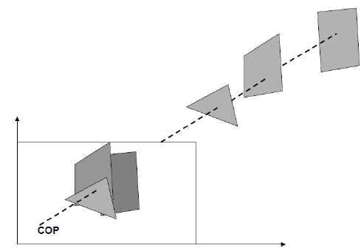
Algorithm

Step-1 − Set the buffer values −

  - Depthbuffer (x, y) = 0

  - Framebuffer (x, y) = background color Step-2 − Process each polygon (One at a time)

  - For each projected (x, y) pixel position of a polygon, calculate depth z.

  - If Z > depthbuffer (x, y)

    - Compute surface color,

    - set depthbuffer (x, y) = z,

    - framebuffer (x, y) = surfacecolor (x, y)

Advantages

- It is easy to implement.

- It reduces the speed problem if implemented in hardware.

- It processes one object at a time.

Disadvantages

  - It requires large memory.

  - It is time consuming process.

- Scan-Line Method

This image-space method for removing hidden surfaces is an extension of the scan-line algorithm for filling polygon interiors where, we deal with multiple surfaces rather than one. Each scan line is processed with calculating the depth for nearest view for determining the visible surface of intersecting polygon. When the visible surface has been determined, the intensity value for that position is entered into the refresh buffer.

To facilitate the search for surfaces crossing a given scan line, we can set up an active list of edges from information in the edge table that contain only edges that cross the current scan line, sorted in order of increasing x. In addition, we define a flag for each surface that is set on or off to indicate whether a position along a scan line is inside or outside of the surface. Scan lines are processed from left to right. At the leftmost boundary of a surface, the surface flag is turned on; and at the rightmost boundary, it is turned off.
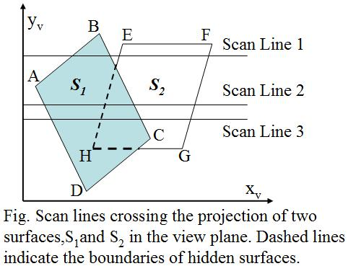

The active list for scan line -1 contains information from the edge table for edges

AB, BC, EH, and FG. For positions along this scan line between edges AB and BC, only the flag for surface S1 is on. Therefore, no depth calculations are necessary, and intensity information for surface S1 , is entered from the polygon table into the refresh buffer. Similarly, between edges EH and FG, only the flag for surface S2 is on. NO other positions along scan line-1 intersect surfaces, so the intensity values in the other areas are set to the background intensity.

For scan lines 2 and 3, the active edge list contains edges AD, EH, BC, and FG. Along scan line 2 from edge AD to edge EH, only the flag for surface S1 , is on. But between edges EH and BC, the flags for both surfaces are on. In this interval, depth calculations must be made using the plane coefficients for

the two surfaces. For this example, the depth of surface S1 is assumed to be less than that of S2 , so intensities for surface S1 are loaded into the refresh buffer until boundary BC is encountered. Then the flag for surface S1 goes off, and intensities for surface S2 are stored until edge FG is passed.

D. Area-Subdivision Method

The area-subdivision method takes advantage by locating those view areas that represent part of a single surface.
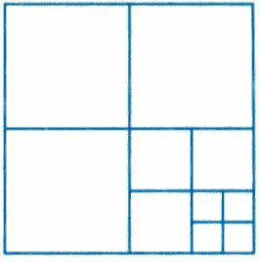
Divide the total viewing area into smaller and smaller rectangles until each small area is the projection of part of a single visible surface or no surface at all. Continue this process until the subdivisions are easily analyzed as belonging to a single surface or until they are reduced to the size of a single pixel. An easy way to do this is to successively divide the area into four equal parts at each step. There are four possible relationships that a surface can have with a specified area boundary.

- Surrounding surface − One that completely encloses the area.

- Overlapping surface − One that is partly inside and partly outside the area.

- Inside surface − One that is completely inside the area.

- Outside surface − One that is completely outside the area.
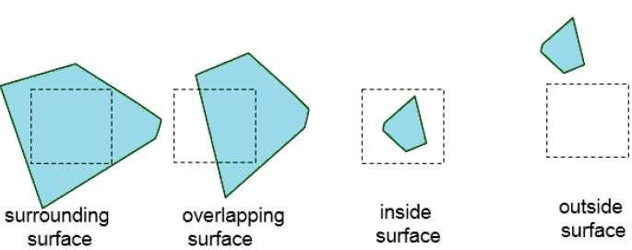

The tests for determining surface visibility within an area can be stated in terms of these four classifications. No further subdivisions of a specified area are needed if one of the following conditions is true −

  - All surfaces are outside surfaces with respect to the area.

  - Only one inside, overlapping or surrounding surface is in the area.

  - A surrounding surface obscures all other surfaces within the area boundaries.

- A-Buffer Method

The A-buffer method is an extension of the depth-buffer method. The A-buffer method is a visibility detection method developed at Lucas film Studios for the rendering system Renders Everything You Ever Saw (REYES).

The A-buffer expands on the depth buffer method to allow transparencies. The key data structure in the A-buffer is the accumulation buffer.
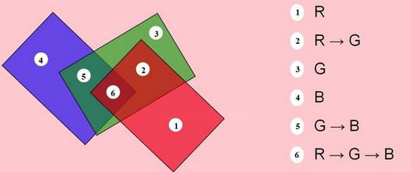

Each position in the A-buffer has two fields −

- Depth field − It stores a positive or negative real number

- Intensity field − It stores surface-intensity information or a pointer value

- If depth >= 0, the number stored at that position is the depth of a single surface overlapping the corresponding pixel area.

- If depth < 0, it indicates multiple-surface contributions to the pixel intensity. The intensity field then stores a pointer to a linked list of surface data.

- The surface buffer in the A-buffer includes −

  - RGB intensity components

  - Opacity Parameter

  - Depth

  - Percent of area coverage

  - Surface identifier
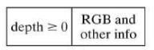

The algorithm proceeds just like the depth buffer algorithm. The depth and opacity values are used to determine the final color of a pixel.

F. Depth Sorting Method

Depth sorting method uses both image space and object-space operations. The depth-sorting method performs two basic functions −

- First, the surfaces are sorted in order of decreasing depth.

- Second, the surfaces are scan-converted in order, starting with the surface of greatest depth.

The scan conversion of the polygon surfaces is performed in image space. This method for solving the hidden-surface problem is often referred to as the painter's algorithm.
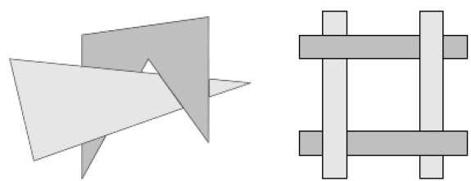
The algorithm begins by sorting by depth.

- Sort all surfaces according to their distances from the view point.

- Render the surfaces to the image buffer one at a time starting from the farthest surface.

- Surfaces close to the view point will replace those which are far away.

- After all surfaces have been processed, the image buffer stores the final image.

Example:

Assuming we are viewing along the z axis. Surface S with the greatest depth is then compared to other surfaces in the list to determine whether there are any overlaps in depth. If no depth overlaps occur, S can be scan converted. This process is repeated for the next surface in the list. However, if depth overlap is detected, we need to make some additional comparisons to determine whether any of the surfaces should be reordered.
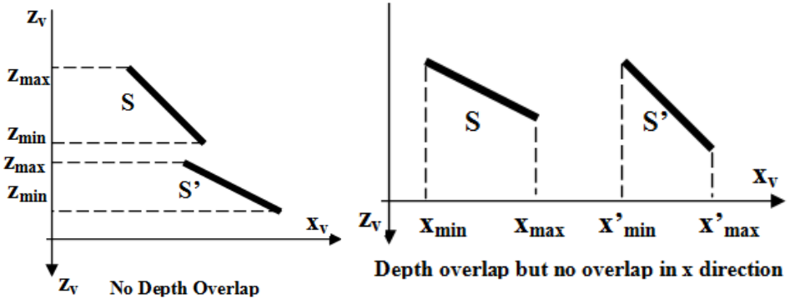

G. BSP Tree Method

A binary space partitioning (BSP) tree is an efficient method for determining object visibility by painting surfaces onto the screen from back to front as in the painter's algorithm.

The BSP tree is particularly useful when the view reference point changes, but object in a scene are at fixed position.

Applying a BSP tree to visibility testing involves identifying surfaces that are "inside" or "outside" the partitioning plane at each step of space subdivision relative to viewing direction. It is useful and efficient for calculating visibility among a static group of 3D polygons as seen from an arbitrary viewpoint.

In the following figure,

 |  | P₁ |  |  |  |  | P₂ |  |  | C
 | f | P₁ | b |  | View
 |  |  |  |  |  |  | A
 | P₂ |  | P₂
f |  | b f |  | b |  |  | Front | B
A | C |  | B | D |  |  | Back
A | C | (a) | B | D |  |  |  |  |  | Front
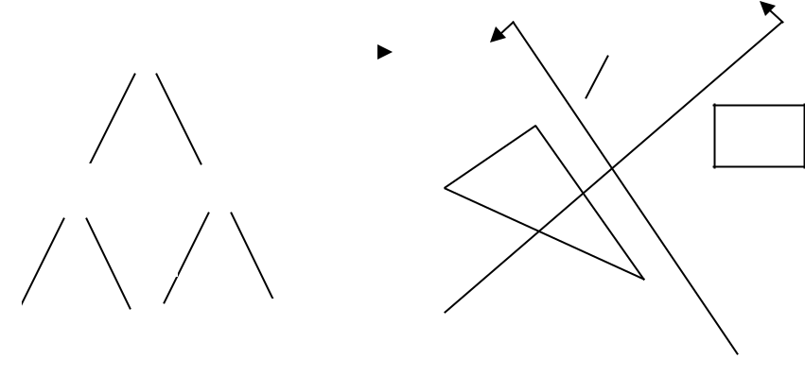

P₁

D

Back (b)

.

Here plane P1 partitions the space into two sets of objects, one set of object is back and one set is in front of partitioning plane relative to viewing direction. Since one object is intersected by plane P1, we divide that object into two separate objects labeled A and B. Now object A&C are in front of P1, B and D are 4 back of P1.

We next partition the space with plane P2 and construct the binary free as fig (a). In this tree, the objects are represented as terminal nodes, with front object as left branches and behind object as right branches.

When BSP tree is complete, we process the tree by selecting surface for displaying in order back to front. So fore ground object are painted over back ground objects.

